Register now
Online | II Russian Gas Mobility Forum
21-22 April 2022
Moscow

Show Forum Agenda in browser
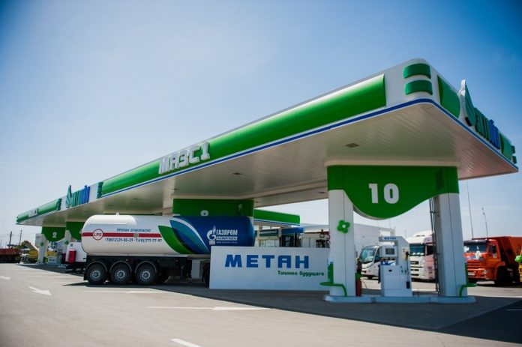
REGISTER NOW

RUSSIAN
GAS MOBILITY
FORUM

21-22 April

The II Russian Gas Mobility Forum will gather stakeholders of the Russian NGV market, incl. equipment producers, representatives from the RF Ministries of Energy, Transport, Natural Resources & Environment, the EEC bodies, businesses, and academia, to discuss the ways for gas mobility to ease the pricing crisis and to contribute to the just energy transition.

Gas in transport is a sustainable, affordable and easily available solution to find positive balance among environmental, social and economic interests!
Join us online to talk on the role and the future of
gas mobility!

AMONGST SPEAKERS
Фотографии спикеров c указанием должности на самой фотографии внизу. Фотографии можно взять с официальных сайтов ведомств и структур, пройдя по активным ссылкам.

P. Zavalny, Chair of the Energy Committee, RF State Duma
O. Aksyutin, Deputy Chairman of the Management Committee, Head of Department 623, Gazprom
V.A. Golubev, Chair of the Council, NGVA Russia
Y.I. Kuzminov, Member of the Academic Council, HSE University
K. Romanov, General Director, Gazprom Hydrogen

The list of speakers will be regularly updated.

The Partner Package gives an opportunity to arrange upon request
on-line presentations and meetings with other participants
within the Forum and two weeks after.

For more information, please, contact:
NGV-forum@ngvrus.ru
Hosted by the National Gas Vehicle Association
NGVA Russia

Активные небольшого размера иконки-ссылки на канал связи Телеграм, сайт Ассоциации, рекламу журнала.

